**DEVELOPMENT OF AN E-PARAMEDICS ONTOLOGY APPLICATION.**

**CASE STUDY: INTERNATIONAL HOSPITAL OF KAMPALA**

**(IHK).**

**BY**

**BALYEJUSA GUSITE**

**REGNO: BIT/46055/151/DU**

**TEL: +256701100204 / +256778224561**

**EMAIL:** [**augsoft.systemz@gmail.com**](mailto:augsoft.systemz@gmail.com)

**AKINTUNDE JAMES KAYODE**

**REGNO: BIT/46978/152/DF**

**TEL: +256785815258**

**Email:** [**akintundejames@gmail.com**](mailto:akintundejames@gmail.com)

**&**

**UGER TERHEMBA PAUL**

**REGNO: BCS/54403/151/DF**

**TEL: +256757092537**

**EMAIL:** [**Ugerpaul5@gmail.com**](mailto:Ugerpaul5@gmail.com)

**A PROJECT REPORT SUBMITTED TO THE SCHOOL OF COMPUTING AND INFORMATION TECHNOLOGY AS A PARTIAL FULFILMENT FOR THE AWARD OF A BACHELOR’S DEGREE OF INFORMATION TECHNOLOGY AT KAMPALA INTERNATIONAL UNIVERSITY.**

**MARCH, 2018**

# **DECLARATION**

This is a declaration that this work is original and has not been presented elsewhere and it is done din partial fulfillment of award of bachelor’s degree of the school of computing and information technology. We confirm that the work has not been submitted to any other institution of higher learning for award of degree.

Name: BALYEJUSA GUSITE

Sign: ………………………………… Date: …………………………….

Department of Information Technology

School of computing and Information Technology

Kampala International University

Name: AKINTUNDE JAMES KAYODE

Sign: ………………………Date: …………………………

Department of Information Technology

School of computing and Information Technology

Kampala International University

Name: UGER TEHERMBA PAUL

Sign: ……………………Date: ……………………

Department of Computer Science

School of computing and Information Technology

Kampala International University

# **APPROVAL**

I hereby confirm under my signature that I was personally involved in supervising this project and the report therefore is their original effort.

Sign: ………………………...………………… Date: ………………………………

Supervisor’s Name: ……………………………………………………………………….

Department of Computer Science

School of computing and Information Technology

Kampala International University

# **DEDICATION**

This work is dedicated to Almighty God who enabled us to accomplish this project successfully and our parents for their care and support always.

# **ACKNOWLEDGEMENT**

We would like to thank God the Almighty for granting us good health and enabling us to undertake this project. We remain forever thankful to Him.

Sincere thanks goes to all our lecturers who taught us for the three years in KIU School of Computing and Information Technology and appreciate their fatherly guide, advice and knowledge which always aimed at making us excel in our field of endeavors.

We, in particular thank Dr. Fagbolu Olutola Olaide our project supervisor for his endless advices, courage he put in us, guidance and friendly approach to us during our project work.

We also extend our thanks to our fellow students and our entire class for their prayers and support, the great memories, ideas shared, commitment and the great team we had that made the working environment favorable and interactive.

May God bless you All.

# **TABLE OF CONTENTS**

**DECLARATION** ii

**APPROVAL** iii

**DEDICATION** iv

**ACKNOWLEDGEMENT** v

**TABLE OF CONTENTS** vi

**LIST OF FIGURES** ix

**LIST OF TABLES** x

**LIST OF ABBREVIATIONS** xi

**ABSTRACT** xii

**CHAPTER ONE** 1

**1.0** **Introduction** 1

**1.1 Background of the Study** 1

**1.2 Problem Statement.** 2

**1.3 Objectives of the study** 3

1.3.1 General objective 3

1.3.2 Specific objectives 3

1.4 Justification of the study 3

**1.5 Scope of the project** 4

1.5.1 Geographical Study 4

**1.6 The Conceptual Framework** 5

**CHAPTER TWO** 6

**LITERATURE REVIEW** 6

**2.0** **Introduction** 6

**2.1 Existing Systems.** 7

**2.2 Types of Information System** 7

2.2.1 Qualities of a Good Information System. 8

2.2.2 Merits of Information Systems 9

2.2.3 Weakness. 9

**2.4 system development life cycle** 10

2.4.1 The traditional predictive approaches to the SDLC 12

2.4.2 The newer adaptive approaches to the SDLC 13

2.4.3 Activities of each SDLC phase 16

**CHAPTER THREE** 20

**METHODOLOGY** 20

**3.0 Introduction** 20

**3.1 Population of study** 20

3.1.1 Sampling methods 20

3.1.2 Sample size 20

3.2.1 System development languages. 22

3.2.2 Firebase Database authenticity 22

3.2.3 Firebase Hash maps 24

**3.3 Data Collection Methods.** 24

3.3.1 Focused group discussions. 24

3.3.2 Interviewing. 24

3.3.3 Observation. 25

**CHAPTER FOUR** 26

**DATA PRESENTATION, ANALYSIS AND SYSTEM DESIGN** 26

**4.0 Introduction** 26

4.1 Data analysis and presentation 26

4.1.1 Respondents 26

**4.2 Findings/Results** 29

**4.3 System Study** 29

**4.4 System Analysis** 30

4.4.1 Existing medical service delivery System. 30

4.4.2 Requirements Specifications 30

4.4.3 User Requirement 30

4.4.4 Functional and Non Functional Requirements 31

4.4.5 System Requirement 31

**4.5 System Design** 32

4.5.1 Logical Model 33

4.5.2 System Architecture 34

**4.6 System Interfaces** 34

4.6.1 Login Form and Doctors page. 35

4.6.2 Doctors page. 35

4.6.3 System start up page. 36

4.6.4 Registration page. 36

4.6.5 Firebase database of the system 37

**CHAPTER FIVE** 38

**SUMMARY, LIMITATION, CONCLUSION AND RECOMMENDATIONS** 38

**5.0 Introduction** 38

**5.1 Summary** 38

**5.2 Limitations** 38

**5.3 Conclusions** 38

**5.4 Recommendations** 39

**5.5 Opportunity and Lesson Learned** 39

**5.6 References** 40

**5.7 Appendix 1** 41

5.8 Appendix 2 42

# **LIST OF FIGURES**

Figure 1.0 Conceptual Framework Of EPO................................................................................5

Figure 2.0 Illustrates The Five Phases Of A Traditional SDLC….............................................11

Figure 2.1 Explains The Five Phases Of A Traditional SDLC...................................................11

Figure 2.2 Predictive Versus Adaptive Approaches Of SDLC.........................................…….12

Figure 2.3 Iterative Spiral Model.........................................................................................…...14

Figure 1.4 Iteration Model...........................................................................................................15

Figure 3.0 E-Paramedics Ontology System Design And Data Flow...........................................21

Figure 3.1 Authenticity System Illustration................................................................................23

Figure 4.0 Patients Opinions On The Current System Bar Chart................................................27

Figure 4.1 Medical Personnel’s Opinions On Current System Bar Chart...................................28

Figure 4.2 E-Paramedics Ontology System Design....................................................................32

Figure 4.3 E-Paramedics Ontology Logical Model.....................................................................33

Figure 4.4 E-Paramedics Ontology System Architecture............................................................34

**Figure 4.5 System Login Form......................**...........................................................................35.

Figure 4.6 Doctors Page..............................................................................................................35

**Figure 4.7** System start up page..................................................................................................36

Figure 4.8 Registration Page.......................................................................................................36

**Figure 4.9** Firebase database of the system................................................................................37

# **LIST OF TABLES**

Table 4.0 Respondents Involved..................................................................................................26

Table 4.1 Percentage Of Medical Personnel’s Responds On Current System.............................27

Table 4.2 Percentage Of Patients Responds On Current System.................................................27

Table 4.3 Showing The Patients’ Response.................................................................................28

Table 4.4: Interview Analysis Of Medical Personnel..................................................................29

Table 4.5 Hardware Requirement................................................................................................31

Table 4.6 Software Requirements................................................................................................31

# **LIST OF ABBREVIATIONS**

IHK International Hospital of Kampala

PHP Hypertext Preprocessor.

MYSQL My Structured Query Language.

STD Sexually Transmitted Diseases.

ENT Ear Norse And Throat Specialists.

WHO World Health Organization.

UTI Urinary Transmitted Infection.

OMC Online Medical Consultation.

RACGP Royal Australian College Of General Practitioners.

IT Information Technology.

DFD Data Flow Diagrams.

OOP Object oriented programming.

SDLC System Development Life Cycle.

EPO E-paramedics Ontology.

# **ABSTRACT**

Computer applications specification for online medical services delivery augment the obtainability and convenience of old-fashioned medical center’s mode of health care provision to the general public, these services were often manual, though effective. Currently, researchers and software developers are having sleepless night in order to devise mechanisms for automating the healthcare service delay hence further increasing the life expectancy, and above all create a global version of accessibility to medical services virtually without limits or physical boundary.

The advancement in technology has fueled the achievement of these kind of goals and objectives by availing different, easy and secure modes of software development with container management systems like Word Press Sites, Drupal and Joomla among others. Furthermore, one can develop a mobile application that can be accessible to whoever has a smart phone that can connect to the network and development of web systems for those with desktops, laptops, note book, pro books and some personal digital assistants that can support web systems.

Availability of such diversification has not only automated, eased, facilitated access to different model of consultancy across the entire universe but also given a chance to the humans in remote areas to gain access to medical tips, advice, counselling on health issues such as family planning, reproductive challenges among others.

However, in 2017, the population of Kampala was 1,353,189 peoples with a death rate of 10.2%, a birth rate of 42.9% and a migration rate of 0.7% migrants. but according to WHO, it is 42,445,425 as at 2018 This clearly portrays the expected growth of the general population of Kampala as a single district, this implies that the number of medical facilities and medical centers should as well be improved and perhaps new ones be constructed which happens not to be achieved as expected.

This led to the struggle between different peoples for medical services from the available few medical centers. At the end of the day, some patients are unattended to hence increasing the death rate and as researchers, we came up with E-paramedics ontology to curb most of the challenges by providing an online version of health care service delivery.

E-paramedics ontology models were replicated to avail basics of health care service delivery to the patients within Kampala district through this medical application, medical personnel’s can contact the patients online as a way to follow up for further medical assistance whenever the need arises.

Consequently, life expectancy would be enhanced and general delivery of health care services would be improved.

# **CHAPTER ONE**

## 

## **Introduction**

Kampala is one of the districts located in the central region of Uganda neighboring with other districts like Mukono, Wakiso, Entebbe, and Masaka among others. Kampala has increasing population from social, political and economic spheres of life with several diversity and heterogeneity, due to the fact that Kampala is the capital city of Uganda, a lot of people both from the Ugandan border and abroad come in for business transactions and seeking better medical facilities among others Kampala has different nationals with a total population of 1,353,189 peoples, a death rate of 10.2%, a birth rate of 42.9% and a migration rate of 2.7% migrants as per the study of the WHO in 2017.

## **1.1** **Background of the Study**

One of the greatest opportunities of the 21st century is the potential to safely harness the power of the technology revolution to meet the challenges of improving health and providing better, safer, sustainable care for all. UK National Information Board, November 2016.

Technology supported medical consulting is viewed by many as at least a partial solution to the complex challenges of delivering healthcare to an ageing and increasingly diverse population. the health service faces rising rates of chronic illness and dependency, but also a proportion of citizens who are confident to self-manage illness and improved long-term outlook for serious conditions such as cancer.

The UK's National Information Board argued that to respond effectively to these demographic and epidemiological trends, needed a different kind of health service in which the traditional outpatient consultation.

Remote consultations offer potential advantages to patients (who are spared the cost and inconvenience of travel) and the healthcare system (eg, they may be more cost-effective). but fears have been expressed that they may be clinically risky and/or less acceptable to patients or staff, and they bring significant technical, logistical and regulatory challenges.

The evidence base on remote consultations by video technology such as Skype is currently sparse but has begun to accumulate. in particular, a recent review identified 27 published studies of the use of Skype in clinical care, all but one of which reported positive benefits. Most of these studies were brief descriptions of small, pilot-stage projects (some with as few as five patients). below, we review the higher quality primary studies from Arnfield and colleague's review that are relevant to our own study along with some additional studies published recently.

A study of family-based behavioral support for adolescents with poorly controlled type diabetes mellitus focused on the ‘working alliance’ that is, the strength of the working relationship between patients, caregivers and healthcare professionals. the authors found that 10 sessions delivered via Skype were as effective as 10 face-to-face sessions at maintaining the working alliance. Adherence to treatment and glycaemic control were also similar in the Skype and face-to-face groups.

**Results and Discussions**

Human emotionalism, biasness, tiredness, double standards, individual’s background, unreliability and dishonesty determined the way how medical personnel respond and handle patients as discussed below;00

Human emotions were triggered by unethical conduct by the either the medical personnel or patient, prior events before coming to a place of work for instance household quarrelling, accidents, deaths, etc. these factors also determine physical interaction between the medical personnel and patients which further affect the kind of medical services rendered to the patients.

Financial status of both the medical personnel and the patients also determined the kind of response from the medical personnel. it was found out that most medical personnel provide good quality services to patients who look wealthy and responsible. Young and shallow-pocket looking individuals were not treated with esteem and considerate.

## **1.2 Problem Statement.**

Kampala has an increasing population from social, political and economic spheres of life with several diversity and heterogeneity, Kampala has different nationals who suffer diseases of different kinds leading to patients of different nationalities to seek for medical attention when need arises but with few medical specialists, patients end up in long queues waiting for services from the few medical specialists while some patients find it hard to discuss some diseases like STD’s in clinics where a number of people may be listening hence privacy is encouraged. Furthermore, because of busy schedules, some patients like bankers, CEOs and other executives hardly get time off their jobs that they can use to visit clinics for immediate consultation on different signs and symptoms, in addition, medical tips are too crucial in one’s life, unfortunately almost the greatest number of peoples do not get it promptly as well as carrying out body check-ups to know their stand.

The absence of an electronic medical services delivery system to eliminate human conflict, biasness, among others can be addresses by the e-paramedics system that will bridge the gap between the patients and doctors.

## **1.3 Objectives of the study**

Objectives of the study are divided into two categories;

### 1.3.1 General objective

* To develop an e-paramedics ontology application for IHK.

### 1.3.2 Specific objectives

* Revising the existing system of medical service delivery system for IHK.
* Itemizing challenges in the existing medical service delivery system.
* Developing an e-paramedics ontology application for IHK.
* Test and validate an e-paramedics ontology application for IHK.

### 1.4 Justification of the study

**To medical institutions.**

The research study exposed the hindrances that limit the adoption of online medical services delivery. E-paramedics ontology enhanced hospital policy provider solution to eradicate these hindrances so as to deliver electronic medical services.

The study advocated for more clients and automatically harness more clients which consequently increased income generation.

E-paramedics ontology delivered medical services by obliterating challenges of conventional medical services in which limited space, queues, non-availability of specialist and so on where no longer be part of the challenges. Patients could be attended to online with little or no assistance of other medical personnel.

In fact, the hospitals can deploy the system in different sectors thereby further automating service delivery to patients in almost all units and its departments.

**Developers and Researchers**

Demonstrating research innovations in a real environment is valuable for the public to appreciate the work. The software publicized the research on online while medical service delivery procedures are enhanced. Although there could be need for improvement as the software are delivered to use in medical institutions. The software can serve as a test case for implementing new and innovative ideas in a rapidly diverse environment. The outputs of the project are available to all interested researchers.

This software is reliable enough to be used as a module (library) for developing other systems with many different components. Flexibility and ease of use were major considerations in the development of this system.

Response to patients or clients’ problems, patients or clients have a direct access to all the necessary medical personnel and medical care as it concern their particular problems. Problems of getting firsthand information from the real people because sometimes we think that bureaucracy has made patients or clients not to get firsthand information from people who matter. With the introduction of this kind of system, firsthand information was got thus removing the red tape.

**To Patients or Clients.**

E-paramedics ontology cut down the high cost of consulting medical personnel in hospitals like International Hospital of Kampala. This granted people chance to easily get diagnosis or required information about the complications in their daily life, information about commonly seen diseases such as air borne diseases, infections, STD’s, UTI’s, among others. Furthermore, this study eradicated the transportation expenses of patients from and to the hospital for cases like consultations as the Doctors can be accessed through our project called e-paramedics ontology.

Convenience at once comfort is offered through the way consultation is made at with online and real-time facilities. High level of privacy is delivered to the patients with one on one interaction with the medical specialist unlike conventional approach where by you meet around five medical personnel and you are supposed to discuss your complications that need a form of privacy for instance cases of STD’s which often make most peoples uncomfortable hence being shy to explicitly explain themselves and get full assistance from the medical personnel.

In cases of clients or patients who are pre-occupied with office work, they can through their mobile phones use this application to consult medical personnel in time because they might hardly get time to visit the hospitals yet the diseases or infections can be aggravated hence leading to further complications or untimely death.

## **1.5 Scope of the project**

The system accessible with in Kampala district patients and fully functional in different medical sectors like ENT specialists among others which will be achieved by using programming languages such as Android Studio, PHP, Java host of other mobile technology application that will avail platform for patients and medical institution. This research work will bring about easy communication and health care services (24 hours in 7 days/365) for patients.

### 1.5.1 Geographical Study

Kampala district has a lot of sectors or divisions from which patients need to access an online medical facilities such as Ear-Nose and Throat (ENT), Tuberculosis (TB), sexually transmitted disease (STD) among others. This study will be within the boundaries of the Kampala district

## **1.6 The Conceptual Framework**

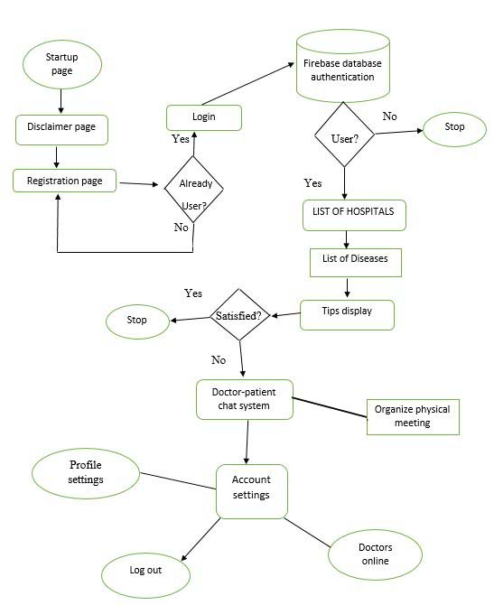

*Figure 1.0 conceptual framework of EPO.*

# **CHAPTER TWO**

# **LITERATURE REVIEW**

## **2.0** **Introduction**

In this section the research, location and analysis of the existing knowledge related to the subject of inquiry are explored and cited. It also sells at the relationship of the proposed research for purposes of good representation and critical review of the existing literature.

E-paramedics ontology was the term used in this chapter to refer to internet-based remote patient-doctor (consumer-provider) medical consultations. This can be regarded as part of telemedicine where the term “Remote Consultation” refers to “consultation via remote telecommunications, generally for the purpose of diagnosis or treatment” (NLM, 2014).

In E-paramedics ontology, the services are usually open to patients with a wide range of medical needs coming from different regions or countries. Patients may choose or be assigned to any doctor / medical personnel (provider) who is available online. They are not restricted to a specific provider either by previous knowledge or by geographical closeness.

The aim of the research reported in this chapter is to explore medical practices in Kampala district. It examines features and themes evident in the literature and in a range of currently operating medical services.

Telemedicine as a term is often used to refer to the mode of access medical services through internet and there are no universally accepted definitions of these terms (Bailey, 2011). Consultations over internet have many names: teleconsultation (Verhoeven et al., 2010, Deldar et al., 2011), e-Visit (Padman et al., 2012, Mehrotra et al., 2013, Handler, July 2013, Adamson and Bachman, 2010, Albert et al., 2011), e-Consultation (Liddy et al., 2013, Drop et al., 2012), video consultation (Jiwa and Meng, 2013, Joseph et al., 2012, Smith et al., 2012), or online medical consultation (Brockes et al., 2012, Bailey, 2011, Braverman and Samsonov, 2011, Lu et al., 2011, Medaglia and Andersen, 2010).

In the US, the term e-visit is more common. However, the term is associated in many references with the asynchronous form of OMC (Gidwani et al., Mehrotra et al., 2013). In Australia, the common term is “video consultation”, apparently referring to the synchronous form of OMC. To have a balanced and clear reference for both forms, the term online medical consultation (OMC) appears to be most appropriate.

The same point was affirmed by recent research (Dudas & Crocetti, 2016). OMC was expected to attract demand from patients who live in remote areas, from aged and disabled patients, and from patients with chronic diseases. It may also be favored by young and internet-savvy people, and employees with inflexible working conditions. Academic reviews of telemedicine/OMC/eVisits have cited several advantages for patients such as increased convenience and accessibility to health services, reduced travel and waiting time to see a doctor, and being a more cost-effective delivery mode (Moffatt and Eley, 2011, Albert et al., 2011, ATA, 2012, Moffatt et al., 2010).

## **2.1 Existing Systems.**

Some researchers have studied the use of Skype in the management of chronic diseases. In one study of the management of depression in older housebound adults, participants were randomized to receive either in-person problem-solving therapy, Skype-delivered problem-solving therapy or a weekly telephone call with no therapeutic content. Both the in-person and Skype-delivered problem-solving therapy were effective at reducing depression scores and disability outcomes.

However, at 36-week follow-up, the participants in the Skype arm of the trial experienced significantly better outcomes than those in the in-person condition. The authors speculated that the more focused nature of the Skype-delivered sessions may have been responsible for these sustained benefits. A study of increased social contact among older adults with access to Skype suggests an alternative explanation: Skype itself may be a valuable tool for wider social integration, thus improving mental health.

A 2014 study reported the use of Skype for orthopedic clinical follow-up.  The Skype service was offered to 78 patients following total joint arthroplasty. Participants were invited to communicate with their surgeon via Skype, in addition to their scheduled follow-up appointments, on five separate occasions: 1, 3, 4, 6 and 9 weeks. The authors found that 34 of the 78 underwent at least one Skype consultation, whereas 44 did not have appropriate electronic devices or internet connection to use the Skype service.

There was no significant difference in clinical outcomes for the users and non-users of this service, though the study was probably underpowered to detect one. However, those followed up by Skype had fewer unscheduled in-clinic visits or called the office for medical advice. Those who had had a Skype consultation rated satisfaction as higher than those who had not.

\In a follow-on paper on 228 participants that encompassed the original sample, the authors found that time spent on the consultation and patient-borne costs were lower in the Skype group.  a linked economic evaluation showed that service costs were also significantly lower in the Skype group.

## **2.2 Types of Information System**

There are various types of information management system, these can be deployed into different organizations according to the structure and nature. Below are the named information systems as according to John More. H (systems.net 2015);-

**Decision support system (DSS).**

These are systems that combine data, model and analysis tools for non-routine decision making. DSS are specifically design to help management make decisions in situation where there is uncertainty about the possible outcomes of those decisions. DSS comprises tool and techniques to help gather relevant information and analyze the options and alternatives. DSS often involves use of complex spreadsheet and database to create “what if models”.

**Office Automated System (OAS).**

These are systems designed to increase the product of data workers in an organization. Office automation system improves the productivity of employees who need to process data and information. Perhaps the best example is the wide range of software systems that exist to improve the productivity of employees working in an office or system that allow employees to work from home or whilst on the move.

**Executive support system (ESS).**

These are systems that support non routine decision making through advanced graphics and communications. They gather and summarize the key internal and external information used in an organization.

**Transaction processing system** **(TPS).**

These are systems that perform and record daily routine transactions necessary for businesses. As this implies, TPS are designed to process routine transactions effectively and accurately.

**Management information system (MIS).**

These are systems that serve planning, control and decision making through routine summary and reports. They are mainly concerned with internal source of information. MIS usually take data from the transaction processing systems and summarize it into a series of management reports.

**Knowledge work system (KWS).**

These are systems that aid in the creation integrations of new knowledge in to an organization. KWS exists to help businesses create and share information. These are typically used in an organization where employees create new knowledge and expertise which can then be shared by other people in the organization to create further opportunities.

### 2.2.1 Qualities of a Good Information System.

The following are the qualities of a good information system according to Jantz.D.W (2016).

**Consistency.**

A good information system should be reliable. Data should be processed and compiled with consistency and uniformity. Variations in how data is collected and reported can distort information and trend analysis.

**Effectiveness.**

A good information system should be able to attain its goals or the goals of the organization. To simplify prompt decision making, an organization’s information system should be capable of providing current information to appropriate users.

**Time lines.**

Information system should be designed to expedite capturing, storing and reporting information in a real time scale when needed.

**Efficiency.**

A good information system should allow for input and output by providing an objective for recording and aggregation information. It should be able to quickly collect and edit data, summarize results, and adjust as well as correct errors promptly.

**Performance.**

A good information system should be able to enhance communication among employees, deliver complex material throughout an organization.

### 2.2.2 Merits of Information Systems

* The following merits of computers base information system according to Paul Schubert (2016),
* They are paramount in times of disaster recovery, as paper documents can be lost, causing business millions of losses.
* People are able to access data needed in real time thus enabling them access detailed information.
* They help in organizing and managing documents effectively. Since the data is stored in a highly organized manner, accessing necessary data is very easy.
* Accurate, current and reliable data is provided because data is analyzed correctly and it can be used for decision making in an organization.
* They are deployed for purposes of improve internal efficiency of the organization.
* They increase the level of security and protect the data from being misused because of the high level of user authentications and authorization. Furthermore, they use cryptographic algorithms as a way encrypting the organization’s data traffic rendering it useless to non-intended users.

### 2.2.3 Weakness.

Information sent by use of the internet can easily be eavesdropped or snooped access to and terminated by unauthorized persons before reaching its destination.

Malicious codes can replicate themselves in the database or storage medium of the organization leading destruction or corrupting files and essential records hence causing havoc

## **2.4 system development life cycle**

At Rocky Mountain Outfitters, one of Barbara Halifax’s initial jobs as the project manager for the customer support system project is to make decisions about the approach used to develop the system. all of the options described under this subheading are open to her. We will not describe her final decisions, though, because we use the customer support system example throughout this text as we present more details about all approaches.

Systems analysts solve business problems, for problem-solving work to be productive, it needs to be organized and goal oriented. Analysts achieve these results by organizing the work into projects. a projectis a planned undertaking that has a beginning and an end and that produces a desired result or product.

The term system development projectdescribes a planned undertaking that produces a new information system. Some system development projects are very large, requiring thousands of hours of work by many people and spanning several calendar years. Many system development projects are smaller, lasting a month or two. for a system development project to be successful, the people developing the system must have a detailed plan to follow. Success depends heavily on having a plan that includes an organized, methodical sequence of tasks and activities that culminate with an information system that is reliable, robust, and efficient.

One of the key, fundamental concepts in information system development is the systems development life cycle. Businesses and organizations use information systems to support all the many, varied processes that a business needs to carry out its functions.

There are many different kinds of information systems, and each has its own focus and purpose in supporting business processes. each one of these information systems has a life of its own, and we, as system developers, refer to this idea as the life cycle of a system. During the life of an information system, it is first conceived as an idea; then it is designed, built, and deployed during a development project; and finally it is put into production and used to support the business.

However, even during its productive use, a system is still a dynamic, living entity that is updated, modified, and repaired through smaller projects. This entire process of building, deploying, using, and updating an information system is called the systems development life cycle, or SDLC.

In today’s diverse development environment, many different approaches to developing systems are used, and they are based on different SDLCs. As you might suppose, some approaches have been used for a long time and have varying rates of success.

In the ever- changing world of information technology, new and unique approaches to building systems have emerged, which also have varying success rates. although it is difficult to find a single, comprehensive classification system that encompasses all of the approaches, one useful technique is to categorize SDLC approaches according to whether they are more predictive or adaptive.

These two classifications that represent the end points of a scale from completely predictive to completely adaptive. These four groups of activities are;- planning, analysis, design, and implementation which are sometimes referred to as phasesand they are the elements that provide the framework for managing the project.

Another phase, called the support phaseincludes the activities needed to upgrade and maintain the system after it has been deployed. The support phase is part of the overall SDLC, but it is not normally considered to be part of the initial development project, these are illustrated below.

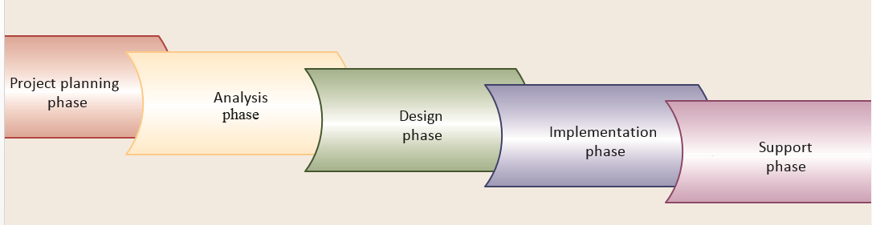

Figure 2.0 Illustrates The Five Phases Of A Traditional SDLC. (Source: journal of online software development life cycle by Herbert Scheldt Johns, retrieved on 15th 02-2018)

**Explanation of the five phases of system development life cycle (SDLC).**

|  |  |
| --- | --- |
| **SDLC phase** | **Objective** |
| Project planning | To identify the scope of the new system, ensure that the project is feasible, and develop a schedule, resource plan, and budget for the remainder of the project |
| Analysis | To understand and document in detail the business needs and the processing requirements of the new system |
| Design | To design the solution system based on the requirements defined and decisions made during analysis |
| Implementation | To build, test, and install a reliable information system with trained users ready to benefit as expected from use of the system |
| Support | To keep the system running productively, both initially and during the many years of the system’s lifetime |

Figure 2.1 explains the five phases of a traditional SDLC.

According to Sat zinger, Jackson, and Stephen, Object Oriented Analysis and Design. Course Technology (2015), A Predictive Approachto the SDLC is an approach that assumes that the development project can be planned and organized in advance and that the new information system can be developed according to the plan. Predictive SDLCs are useful for building systems that are well understood and defined. for example, a company may want to convert its old, mainframe inventory system to a newer networked client/server system. In this type of project, the staff already understands the requirements very well, and no new processes need to be added. So, the project can typically be planned carefully, and the system can be built according to the specifications.

At the other end of the scale, an adaptive approachto the SDLC is used when the exact requirements of a system or the users’ needs are not well understood. In this situation, the project cannot be planned completely in advance. Some requirements of the system may yet need to be determined, after some preliminary development work. developers should still be able to build the solution, but they must be flexible and adapt the project as it progresses.

**Predictive versus adaptive approaches to SDLC**

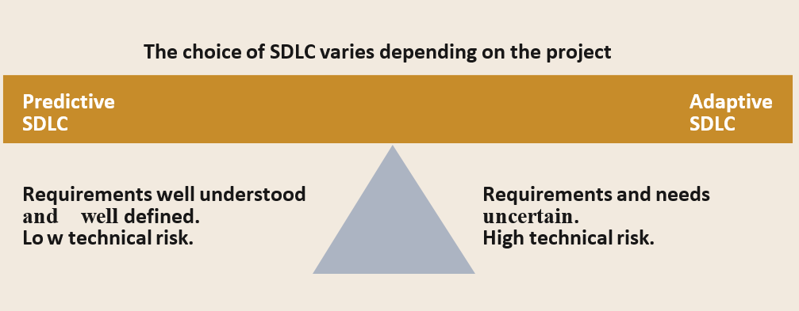

*Figure 2.2 Predictive Versus Adaptive Approaches Of SDLC.*

### 2.4.1 The traditional predictive approaches to the SDLC

The development of a new information system requires several different, but related, activities. In predictive approaches, we first have a group of activities that plan, organize, and schedule the project, usually called project planning activities. these activities map out the overall structure of the project. Next, a group of activities must focus on understanding the business problem that needs to be solved and on defining the business requirements. we refer to this set of activities as analysis activities. the intent is to understand exactly what the system must do to support the business processes.

A third group of activities is focused on designing the new system. Those activities, called design activities, use the requirements that were defined earlier to develop the program structure and algorithms for the new system. Yet another group of activities is necessary to build the system. We call those activities implementation activities and they include programming, testing, and installing the system for the business users.

### 2.4.2 The newer adaptive approaches to the SDLC

Remember that by an adaptive approach, we mean a development approach in which project activities including plans and models are adjusted as the project progresses. Further to the right on the scale is a very popular approach called the spiral model. Thiscontains many adaptive elements, and it is generally considered to be the first adaptive approach to system development.

The life cycle is shown as a spiral, starting in the center and working its way outward, over and over again, until the project is complete. This model looks very different from the static waterfall model and sets the tone for the project to be managed differently.

You can implement a spiral approach in many different ways. The purpose of the planning phase is to gather just enough information to begin developing an initial prototype (discussed next). Planning phase activities include a feasibility study, a high-level user requirements survey, generation of implementation alternatives, and choice of an overall design and implementation strategy.

After the initial planning is completed, work begins in earnest on the first prototype (the blue ring in the figure). a prototypeis a preliminary working model of a larger system. For each prototype, the development process follows a sequential path through analysis, design, construction, testing, integration with previous prototype components, and planning for the next prototype. when planning for the next prototype is completed, the cycle of activities begins again. although the figure shows four prototypes, the spiral model approach can be adapted for any number of prototypes.

A key concept of the spiral approach is the focus on risk although there are many choices about what to focus on in each iteration, the spiral model recommends identifying risk factors that must be studied and mitigated. the part of the system that appears to have the greatest risk should be addressed in the first iteration.

Sometimes the greatest risk is not one subsystem or one set of system functions; rather, the greatest risk might be the technological feasibility of new technology. if so, the first iteration might focus on a prototype that proves the technology will work as planned. Then the second iteration might begin work on a prototype that addresses risk associated with the system requirements or other issues. Another time, the greatest risk might be user acceptance of change. So the first iteration might focus on producing a prototype to show the users that their working lives will be enriched by the new system. below is an illustration of the iterative spiral model.

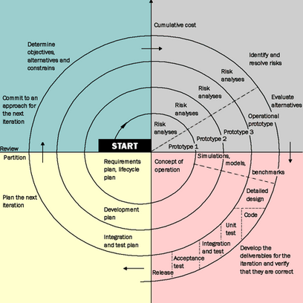

Figure 2.3 Iterative Spiral Model (Source: department of project management cycle online resources by Gratz Augsoft Zanders, retrieved on 10th 03-2018)

Iteration is a system development process in which work activities analysis, design, implementation are done once, then again, and yet again on different system components; they are repeated until the system is closer to what is ultimately needed.

Figure above which shows the spiral model, uses the term iteration. In problem solving, iterations are used to divide a very large, complex problem into smaller, more easily managed problems. each small problem is solved in turn until the large problem is solved. System development uses iteration for the same purpose. we take a large system and figure out some way to partition it, or divide it into smaller components. then we plan, analyze, design, and implement each smaller component. Of course, we also add an integration step to combine the smaller components into a comprehensive solution. This approach is frequently called an iterative approach to the SDLC. Many of the more popular adaptive approaches today use iteration as a fundamental element of the approach. Figure below illustrates how an iterative approach works.

Iteration means that work activities analysis, design, and implementation are done once, then again, and yet again; they are repeated. With each iteration, the developers refine the result so that it is closer to what is ultimately needed. Iteration assumes that no one gets the right result the first time. with an information system, you need to do some analysis and then some design before you really know whether the system will work and accomplish its goals. then you do more analysis and design to make improvements.

In this view, it is not realistic to complete analysis (define all of the requirements) before starting work on the design. Similarly, completing the design is very difficult unless you know how the implementation will work (particularly with constantly changing technology). So you complete some design, then some implementation, and the iteration process continues more analysis, more design, and more implementation. naturally, the approach to or the amount of iteration depends on the complexity of the project.

You can organize iterations in several ways. one approach is to define the key functions that the system must include and then implement those key functions in the first iteration. After they are completed, the next set of required, but less crucial, system functions are implemented. Finally, optional system functions, those that would be satisfactory are implemented in the last iteration. Another approach is to focus on one subsystem at a time.

The first subsystem implemented contains the core functions and data on which the other subsystems depend. Then the next iteration includes an additional subsystem, and so on as illustrated below in an iterative model of system development life cycle.

**Iteration of system development activities**

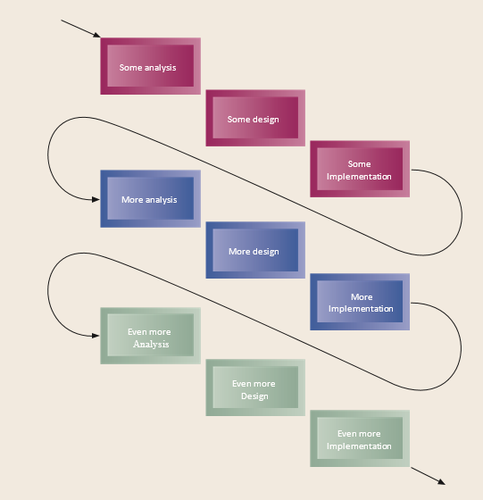

Figure 2.4 Iteration Model (Source: journal software development life cycle by Herbert Scheldt Johns, retrieved on 15th 02-2018)

### 2.4.3 Activities of each SDLC phase

**Project planning phase**

The primary objectives of project planning are to identify the scope of the new system, ensure that the project is feasible, develop a schedule, resource plan and budget for the remainder of the project. we identified five activities in project planning:-

* Define the problem.
* Produce the project schedule.
* Confirm project feasibility.
* Staff the project.
* Launch the project.

The most important activity of project planning is to define precisely the business problem and the scope of the required solution.

At this stage in the project, you will not know all of the functions or processes that will be included within the system. However, it is important to identify the major uses of the new system and the business problems that the new system must address.

The two activities of producing the project schedule and staffing the project are clearly closely related. a detailed project schedule listing tasks, activities, and required staff is developed. Fortunately, some excellent methods and tools are available to provide support for this activity, which are explained in the next chapter. Large projects require elaborate schedules with specific, identifiable milestones and control procedures, and a critical part of this phase is identifying the necessary human resources and planning to acquire them at the required times during the project.

The next major element is to confirm that the project is feasible. Many projects are initiated as part of an enterprise-wide strategic plan. Within the overall plan, each project must also stand on its own merit. Feasibility analysis investigates economic, organizational, technical, resource, and schedule feasibility. Each of these types of feasibility analysis is explained in more detail in the next chapter.

Finally, the total plan for the project is reviewed with upper management, and the project is initiated. Initiation of the project entails allocating funds, assigning project members, and obtaining other necessary resources such as office and development tools. an official announcement often communicates the project launch.

1. **Analysis phase (activities).**

The primary objective of the analysis activitiesis to understand and document the business needs and the processing requirements of the new system. Analysis is essentially a discovery process. The key words that drive the activities during analysis are discovery and understanding.

**Six primary activities are considered part of this phase**:

* Gather information.
* Define system requirements.
* Build prototypes for discovery of requirements.

**Problem domain-** the area of the user’s business that needs an information system solution and that is being researched. The analysts obtain information about the problem domain by observing the users as they do their work; by interviewing and asking questions of the users; by reading existing documents about procedures, business rules, and job responsibilities; and by reviewing existing automated systems.

In addition to gathering information from the users of the system, the analysts should consult other interested parties. they may include middle management, senior executives, and at times even external customers. Gathering information is the core activity for discovery and understanding. it is not sufficient simply to gather information. analysts must review, analyze, and structure the information obtained so that they can develop an overall understanding of the new system’s requirements.

This activity is called defining the system requirements, and the primary technique that is used is drawing diagrams to express and model the new system’s processing requirements.

1. **Design phase (activities).**

The objective of the design activitiesis to design the solution system based on the requirements defined and decisions made during analysis. High-level design consists of developing an architectural structure for the software components, databases, user interface, and operating environment. low-level design entails developing the detailed algorithms and data structures that are required for software development. Seven major activities must be completed during the design phase:

* Design and integrate the network.
* Design the application architecture.
* Design the user interfaces.
* Design the system interfaces.
* Design and integrate the database.
* Prototype for design details.
* Design and integrate the system controls.

Design activities are closely interrelated and generally are all done with substantial overlap. the network consists of the computer equipment, network, and operating system platforms that will house the new information system. many of today’s new systems are being installed in network and client/server environments. design includes configuring these sequences of interactions. most new information systems must also communicate with other, existing systems, so the design of the method and details of these communication links must also be precisely defined. these are called system interfaces.

Databases and information files are an integral part of information systems for business. The diagrams of the new system’s data storage requirements, developed during analysis, are used to design the database that will support the application portion of the new system. At times, the database for the specific system must also be integrated with information databases of other systems already in use.

During design, it is often necessary to verify the correctness or workability of the proposed design. again, one important verification method is to build working prototypes of parts of the system to ensure that it will function correctly in the operating environment.

In addition, analysts can test and verify alternative design strategies by building prototypes of the new system. Sometimes, if the prototypes are built correctly, they can be saved and used as part of the final system.

Finally, every system must have sufficient controls to protect the integrity of the database and the application program. because of the highly competitive nature of the global economy and the risks associated with technology and security, every new system must include adequate mechanisms to protect the information and assets of the organization.

1. **Implementation phase (activities).**

This phaseresult in the final system being built, tested, and installed. the objective is not only to produce a reliable, fully functional information system, but also to ensure that the users are all trained and that the organization is ready to benefit as expected from use of the system.

All the prior activities must come together to finish in an operational system. below are the five major activities make up the implementation phase:

* Construct software components.
* Verify and test.
* Convert data.
* Train users and document the system.
* Install the system.

The software can be constructed through various techniques. the conventional approach is to write computer programs using a language such as Visual Basic, C#, or Java. Other techniques, based on development tools and existing components, are becoming popular today.

The software must also be tested, and the first kind of testing verifies that the system actually works. Additional testing is also required to make sure that the new system meets the needs of the system’s users.

1. **Support phase (activities).**

The objective of the support activitiesis to keep the system running productively during the years following its initial installation. The support activities begin only after the new system has been installed and put into production, and it lasts throughout the productive life of the system.

The expectation for most business systems is that the system will last for years. during support, upgrades or enhancements may be carried out to expand the system’s capabilities, and they will require their own development projects. Three major activities occur during support:

* Maintain the system.
* Enhance the system.
* Support the users.

Every system, especially a new one, contains components that do not function correctly. Software development is complex and difficult, so it is never error-free. Of course, the objective of a well-organized and carefully executed project is to deliver a system that is robust and complete and that gives correct results.

However, because of the complexity of software and the impossibility of testing every possible combination of processing requirements, there will always be conditions that have not been fully tested and thus are subject to errors. In addition, business needs and user requirements change over time.

Key tasks in maintaining the system include both fixing the errors (also known as fixing bugs) and making minor adjustments to processing requirements. Usually a system support team is assigned responsibility for maintaining the system.

During the productive life of a system, it is also common to make major modifications. At times, government regulations require new data to be maintained or information to be provided. also, changes in the business environment new market opportunities, new competition, or new system infrastructure necessitate major changes to the system.

To implement these major system enhancements, the company must approve and initiate an upgrade development project. An upgrade project often results in a new version of the system.

*Source: Customer support system project, At Rocky Mountain Outfitters by project manager Barbara Halifax’s*

# **CHAPTER THREE**

# **METHODOLOGY**

## **3.0 Introduction**

This is chapter describes the methods employed to meet the objectives of the e-paramedics ontology. Furthermore, it describe the techniques of data collection that were used in the research of the e-paramedics ontology medical application. this chapter also examines the different tools and methods used in the due course of the e-paramedics ontology development.

## **3.1 Population of study**

The study population was Kampala district in which the e-paramedics ontology was to be deployed. Kampala district has different medical center that were visited during the research in order to dig out how best medical facilities are being carried out and the as well how to computerize that mode of delivery thereby making it more convenient and accessible 24/7.

These medical centers include international hospital of Kampala (IHK), Elim-medical center Kansanga, Mulago main hospital (ENT, TB, sections among others), Mulago hospital Kawempe branch, among other.

### 3.1.1 Sampling methods

We employed the purposive and stratified random sampling in our research process.

According to Ashley Crossman, introduction to sociology of [Social Sciences (2017),](https://www.thoughtco.com/social-sciences-4133522) a purposive sample is a non-probability sample that is selected based on characteristics of a population and the objective of the study. we used purposive sampling to get the sample for the study from citizens or the general public including hospitals and we got reliable information that we would get from them. Because the general population was big, in thousands of numbers, we used simple random sampling method to get the sample size from Kampala district. this is because Stratified random sampling is a method of sampling that involves the division of a population into smaller groups known as strata. in stratified random sampling, the strata are formed based on members' shared attributes or characteristics.

These subsets of the strata are then combined to form a random sample.

### 3.1.2 Sample size

In this research projects we used purposive and stratified random sampling techniques due to the large population or sample area that the research covers. These include the different big health centers like international hospital of Kampala, Mulago hospital, and Elime medical center among others. We used these to get information from the medical personnel and patients views as far as given sub divisions under Kampala district.

The study population was divided into strata for easy manipulations then later computed them to represent the entire target population of the research study.

Now suppose we have a population of size N divided into k strata. We take a stratified random sample with ni observations in the ith stratum, which has population size Ni and a population proportion of attributes equal to Pi. Let Pi be the sample proportion in the ith stratum. Our overall sample size is n = Ei ni and the "pooled" estimate of p, pstrat, weights the sample proportions from each stratum according to the population sizes from the strata.

**3.2 Approach for the Development of E-paramedics ontology.**

We chose to use the spiral model and risk analysis aspects of the system development life cycle (SDLC) because the spiral model is a risk-driven [process model](https://en.wikipedia.org/wiki/Software_development_process) generator for software projects. the spiral model guides a team to adopt elements of one or more process models, such as [incremental](https://en.wikipedia.org/wiki/Iterative_and_incremental_development), [waterfall](https://en.wikipedia.org/wiki/Waterfall_model) prototyping basing on the different risk conditions involved in the research project being carried out.

Different aspects from other models like prototyping were also employed and they guided us in developing the system definition and analysis, data flow diagrams (DFD) which were used to show the flow of data in the system as shown below;-

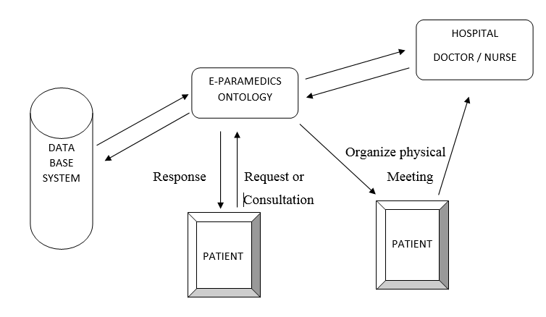

*Figure 3.0 E-Paramedics Ontology System Design and data flow.*

Due to the variances to be encountered in the development process, the system was developed using spiral model approach due to its flexibility during development processes. a key concept of the spiral approach is the focus on Risk. Although there are many choices about what to focus on in each iteration, the spiral model recommends identifying risk factors that must be studied and alleviated. Iterations are used to divide a very large, complex problem into smaller, more easily managed problems. Each small problem is solved in turn until the large problem is solved.

### 3.2.1 System development languages.

In the E-paramedics ontology, we programmed the different interfaces and embed their functionality in them plus the firebase database for signature or user templates storage. This propelled us to use the following integrated development environments and programming language;-

* Android studio 3.0.1
* Extensible markup language
* Python
* Firebase database

The system is built with a firebase driven database which is powered by Android programming language. This typically runs online hence does not have local host mode of execution and it’s among the most secure database system ever better than MySQL and Oracle.

We built the Android application and install the capability of firebase database which gives it the capability to store data. The most amazing truth is that firebase connection with android does not need a language like PHP to connect the application and the database, it’s by default done by firebase database.

### 3.2.2 Firebase Database authenticity

Firebase database has a strong authentication system for security purposes. These include;-

* + Phone contacts
  + Facebook account
  + Email address

This database uses dependencies also known as the common gateway interface that help it achieve data storage. Under these include;-

1. **Image store dependency**. This stores images in the firebase database.
2. **Firebase authentication dependency**. This is for authenticating the user of the application.
3. **Firebase user interface database dependency**.

This dependency enables the hash maps (a form of a table as used in languages like MySQL) utilization. These hash maps store names, status and images in the database.

**Explanation of authentication process.**

We achieved the authenticity by making it possible that one must have any of the accounts above like Facebook, email or phone number to be used as user identification system, when one uses email for example, he or she accesses the deployed application, the application authentication system through the firebase database filters his or her details through the Gmail company (email address provider), keeps the password and only send back the email address feedback to the firebase authentication system for purposes of user authorization or allowing access.

**Authenticity system illustration**

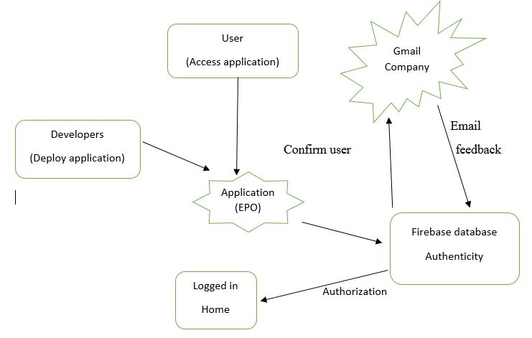

*Figure 3.1 Authenticity system illustration*

### 3.2.3 Firebase Hash maps

Our system having been built using one of the most secure database, it thoroughly authenticate user to ensure all the security elements of CIA thus to say confidentiality, integrity and availability among others. We used hash maps like the following to achieve this security level

1. **Identifier** for email addresses.
2. **Providers and Created** for knowing the dates of creation or insertion of data in the system
3. **Signed in** for giving a detailed report on sign in activities of different user and their operations.
4. **User UID’s**. These are like primary keys (as referred to in other languages like MySQL) assigned to the different system users for easy tracking of operations.

## **3.3 Data Collection Methods.**

The following methods were used during data collection: Observation, Interviewing and focused group discussion as our research methods. We were able to gather raw data from different hospitals and the general public of Kampala district where existing details on the current system were obtained. Verbal interview techniques were used to interview peoples from the different areas of Kampala district.

### 3.3.1 Focused group discussions.

A focus group discussion was held between some medical personnel for example at Elim-medical center and the team members and users or patients to whom the issue seemed relevant. This was because it provided space to discuss particular topics in context where people are allowed to agree or disagree with each other, thereby enabling us to identify or spot out the core values that were be implied in our system.

### 3.3.2 Interviewing.

In this method, just like in the focused group discussion, there was strong conversation about medical facilities or service mode of delivery automation in contrast with the current manual system the researchers and the Staffs of hospitals and the general public or citizens of Kampala district. we also included key informant interviews, which were useful for exploring an individual’s beliefs, values, understandings, feelings, experiences and perspectives of an issue that is to say the e-paramedics ontology.

Individual interviews also allowed us to ask into complex issues, learning more about the contextual factors that govern individual experiences so as to enhance us define particular constraints to be put in our system to reach and achieve set goals and objectives. These interviews were also held to verify the information collected using the observations made by us, the researcher since there was room for digging out further information during the interview.

### 3.3.3 Observation.

The mode of operation of different hospitals and access to medical services in Kampala District was observed being manual whereby if one went to the medical facility premises, they had to sit in queues and wait for medical attention by the trained medical personnel. Even some one who wanted to make a brief consultation had to wait in queues. Unfortunately, some patients were being referred to the next days of operation because of tiredness and time limits for out patients departments.

# **CHAPTER FOUR**

# **DATA PRESENTATION, ANALYSIS AND SYSTEM DESIGN**

## **4.0 Introduction**

The chapter focuses on the data analysis and presentation, system analysis and design, strengths and weaknesses of the current system, Context level diagrams, Entity Relationship Diagrams and the Architectural design.

### 4.1 Data analysis and presentation

This illustrates the various data analysis tools used to scrutinize the data collected by the vast data collection techniques and transformed into information in a pictorial manner of charts and tables. These diagrammatic representations aided us in decision making of requirements employed.

The objective for data analysis and presentation was to designate the functional and non- functional requirements of the system developed. It would present an overview of the Scheme’s stipulations, functional requirements, competences and a description of the target population.

### 4.1.1 Respondents

The illustration below represents the number of target population for data collection and the actual number of people who actively took part in the data collection process.

**Table 4.0 RESPONDENTS INVOLVED**

|  |  |  |  |
| --- | --- | --- | --- |
| **Target population for interview process** | **Number of targeted individuals** | **Number of** individuals **involved.** | **Percentage %** |
| Medical personnel | 150 | 110 | 73% |
| patients | 350 | 320 | 93% |
| total | 500 | 430 | 90% |

**4.1.2 Analysis of the respondents’ opinions about the current system.**

During the data gathering from the respondents, we assembled the correspondents into three five categories that is Agree, Strongly agree, Disagree, Strongly disagree and Not sure. Underneath this we were considering the different challenges being faced from the current system.

The respondents had to weigh the degree of challenges faced before deciding to either agree or disagree with the current system. The table below shows the percentage of both medical personnel and patients on the current system.

**Table 4.1 PERCENTAGE OF MEDICAL PERSONNELS RESPONDS ON CURRENT SYSTEM**

|  |  |  |  |  |  |
| --- | --- | --- | --- | --- | --- |
| TOTAL NUMBER OF RESPONDENTS | AGREED% | STRONGLY AGREED % | DISAGREED% | STRONGLY  DISAGRED% | NOT SURE% |
| 110 | 20 | 10 | 40 | 35 | 5 |

**Table 4.2 PERCENTAGE OF PATIENTS RESPONDS ON CURRENT SYSTEM**

|  |  |  |  |  |  |
| --- | --- | --- | --- | --- | --- |
| TOTAL NUMBER. OF RESPONDENTS | AGREED % | STRONGLY  AGREED% | DISAGREED % | STRONGLY DISAGREED% | NOT SURE% |
| 320 | 30 | 15 | 180 | 75 | 20 |

Figure 4.0 *patients opinions on the current system bar chart*

*Figure 4.1 medical personnel’s opinions on current system bar chart*

**Table 4.3 SHOWING THE PATIENTS’ RESPONSE**

|  |  |  |
| --- | --- | --- |
| **Interview** | **Response** | **Remark** |
| Do you experience any problem with the current medical service delivery system?  How long does it take you to get medical attention? | Long queues during the registration process  Time wastage during the queuing process.  There are possibilities of not being attended to | This shows that current medical services delivery system is not automated and consumes a lot of timed due to long queues. |
| What do you think is the best way to handle such problems? | a system that can save time and also possess a user friendly mode of functionality | This implies that a computerized system is being needed since to them is seems to be part of the solution on existing problems. |
| Please specify some of the features you think the system should have. | Direct access to the medical personnel  Online booking of doctor or  nurse | These features will guide in creating an effective system. |

**Table 4.4: INTERVIEW ANALYSIS OF MEDICAL PERSONNEL.**

|  |  |  |
| --- | --- | --- |
| Interview | Response | Remark |
| How do you rate the performance of the current system? | Tiresome on both sides of a medical personnel and a patient seeking medical attention. | Room for an automated application to cub some of the challenges faced in the day to day process of medical services  delivery to patients |
| How does the current medical services delivery system operate? | Patients incur transport expenses, go to the medical centers and make long queues while waiting for medical attention. | This illustrates how the process is long and tiresome |
| Where does the current system need improvement? | Yes, establishment of a computerized application to replace the manual system is preferred. | This shows that a computerized system will create more good than harm. |
| Which features would you suggest to have? | Real time doctor to patient charting system | Features embedded in the system. |
| Would you like to use computerize system? | Yes | Positive remark for the new system |

## **4.2 Findings/Results**

In reference to the above analysis of different respondents from both medical personnel and patients we experienced that out of 110 medical personnel of 75% were not contented with the current system while out of 320 patients 82.5% were not contented with the system due to the problems they were facing hence they recommend for a computerized E-paramedics ontology application.

## **4.3 System Study**

The study was carried out in Kampala district and the main purpose of the study was to discover how the process of accessing or delivering medical services was being carried out. The system that was being used was entirety manual where one had to move or incur transport expenses, go to the hospital’s premises, in most cases make long queues waiting for medical attention from Doctors and Nurses or counsellors where some patients ended up going home minus being attended to due to few medical personnel in hospitals yet patients were many moreover in queues. Furthermore, Due to busy schedules, some patients like bankers and other officials hardly got time off their jobs that they could use to visit clinics for immediate consultation. Yet even asking time off jobs from employers was also hard because employers took it as an excuse for not working.

## **4.4 System Analysis**

During the system study phase, requirements of E-paramedics ontology were categorized into user requirements, software and hardware requirements.

### 4.4.1 Existing medical service delivery System.

Refer to the literature review, observation, interviews and questionnaires as explained in chapter three, it should be noted that in Kampala district, we were able to analyze existing medical services delivery system as discussed below.

The current services rendered were in a manual mode where by one had to move to hospitals or clinics in order to get medical attention or call the personal doctor which seemed costly and perhaps not afforded by the some citizens of Kampala district.

The current system was not only tiresome but also time consuming and even caused bias since it involved human beings moreover in physical contact (a doctor or nurse and a client or patient) interacting with each other.

The clients recommended that the proposed system should be user friendly, able to respond without errors, operate without bias, and observance of time factor. Context diagrams, Data flow diagrams were used in the analysis and design of the system.

### 4.4.2 Requirements Specifications

After analyzing the data collected, we formulated a number of requirements namely user requirement, system hardware and software attribute. These were grouped as user, functional, non-functional and systems requirements.

### 4.4.3 User Requirement

During data collection, we investigated and found out that currents system caused biasedness in medical personnels who happen to be tired because long working hours which left other patients un attended to, so we found out that best way to settle this was through the E-paramedics ontology in order to provide online services which could also cut consultation fees and saves time because of the real time mode of operation. The users recommended that the proposed system should be user friendly, able to respond without errors, operate without bias, and observance of time factor.

### 4.4.4 Functional and Non Functional Requirements

The following were the desired functionality of the new system.The system should recognize the client’s input and responds relatively to him/her with the aid of the medical personnel’s operation in the hospitals in a way of responding to the inquiries of patients.

Some information should be readily available in form of medical tips on the system main interface thereby saving time because a patient can easily read and take action. It should also display the information the client may need in a written form for example during the real time doctor patient conversations.

And non-functional requirements include the following

The system must verify and validate all user input and users must be notified in case of errors or downtime encountered or detected in the due course of system utilization.

### 4.4.5 System Requirement

This section describes the hardware components and software requirements needed for effective and efficient running of the system.

|  |  |
| --- | --- |
| Hardware | Minimum System requirement |
| Processor | 2.4 GHZ processor speed |
| Memory | 128 MB RAM (256 MB Recommended) |
| Disk space | 80 GB (including 20 GB for database Management system) |
| Display | 800 x 600 colors (1024 x 768 High color- 16 bit Recommended) |

**Table 4.5 Hardware Requirement**

The table above shows hardware components of the machine (computer) that allows the system to function as required for using the E-paramedics ontology.

**Table 4.6 Software Requirements**

|  |  |
| --- | --- |
| Software | Minimum System requirement |
| Operating System | Windows 7, 8, 8.1, 10 |
| Android studio | Version 3.0 or higher |
| .Net framework | Version 3.5 or higher |

The table above shows software requirements recommended to enable the system to run.

## **4.5 System Design**

After interpretation of the data, tables were drawn and process of data determined to guide us in the implementation stage of the project. The tools, which were employed during this methodology stage, were mainly tables and Data Flow Diagrams (DFDs).



*Figure 4.2 E-paramedics ontology system design*

### 4.5.1 Logical Model

This figure shows the logical flow of events in the system, it caters for the time when the user starts or logs in and signs out from the system.



*Figure 4.3 E-Paramedics Ontology Logi**cal model*

### 4.5.2 System Architecture

This gives a high level view of the new system with the main components of the system, the services they provide and how they communicate. The system is implemented using a three-tier architecture that comprises of user interface, command handling codes and command list as illustrated below.

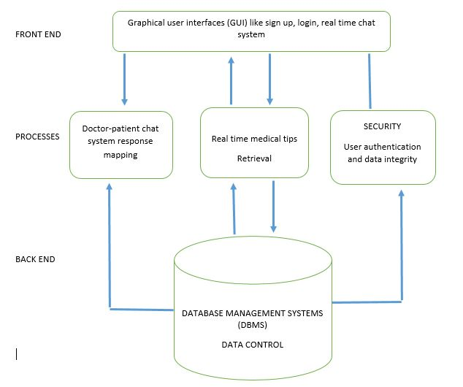

*Figure 4.4 E-Paramedics Ontology System Architecture.*

## **4.6 System Interfaces**

The different interfaces in the E-paramedics ontology applications as reflected below were developed or coded in Android studio 3.1.0 using java, xml, python and a firebase database powered by Android software.

### 4.6.1 Login Form and Doctors page.

This allows the users who claim to be registered in the application to login, the login initiated by the user is further authenticated by the firebase database to ensure that only the rightful user access the application. The doctor’s page show the available medical personnel in the application.

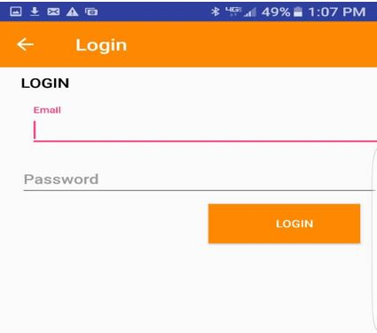

***Figure 4.5*** ***System Login Form.***

### 4.6.2 Doctors page.

This interface gives the users ability to see which medical personnel are available and online in a given hospital so that they can make their choice of whom to interact with in the quest for health care services.

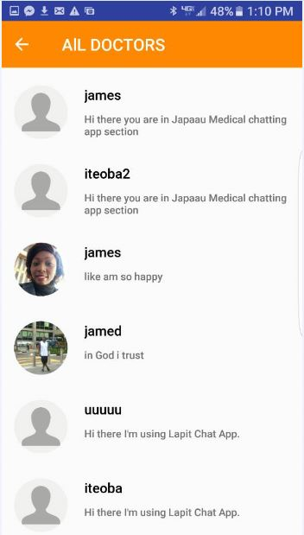

***Figure 4.6 Doctors page.***

### 4.6.3 System start up page.

This is the first page of the system. It automatically plashes off after it’s programmed time and it takes you to the disclaimer page.

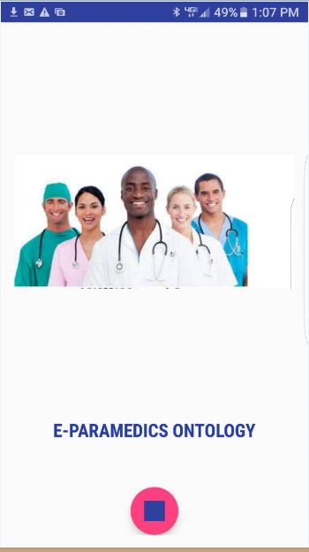

***Figure 4.7 System start up page.***

### 4.6.4 Registration page.

This interface gives the different users of the E-paramedics ontology application room for registering and become user of the system. it also give introductory information about the application.

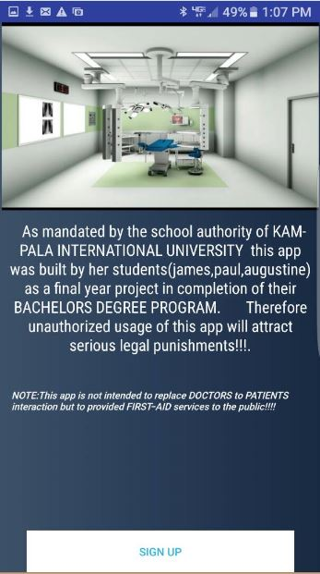

***Figure 4.8 Registration page***

### 4.6.5 Firebase database of the system

This is a live databases system we used for the E-paramedics ontology application, it is powered by android and it uses hash maps for data storage.

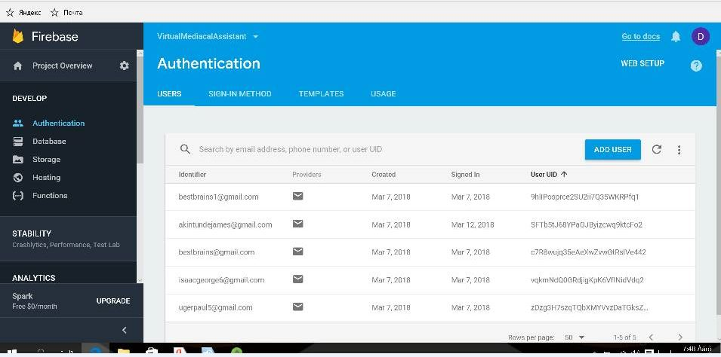

***Figure 4.9 Firebase database of the system***

# **CHAPTER FIVE**

# **SUMMARY, LIMITATION, CONCLUSION AND RECOMMENDATIONS**

## **5.0 Introduction**

This chapter describes the objectives of the system stipulated in earlier chapter, limitation of the system conclusion and recommendation of the system

## **5.1 Summary**

As discussed in the previous chapters, the main problem that we addressed was dealing with provision of online medical services like consultation, doctors booking among others to the general public of Kampala district. It is the above situation that drove us to techniques of developing this E-paramedics ontology to be used in Kampala district to enable the public access online medical services efficiently and effectively.

The project has implemented Most of the objectives stipulated in earlier chapters and offers a number of benefits to the user. Problems Encountered during Data collection: some medical facilities refused to give us information about them, bigger sampling populations for data collection and analysis, insufficient funds to cater for the entire process hence hectic.

Problems Encountered during System Design: Limited time to finish up the work, limited internet in the faculty hence it becomes difficult download and update android studio files 3.0 from the internet and inadequate financial support to facilitate the project.

## **5.2 Limitations**

This section describes those services that are not provided by the system and those include the following.

The medical personnel of a given patient may be offline at that particular time he or she may be needed by the client or patient hence being an inconvenience to the users.

The application favors most those who are fluent or know English since it’s the official language mostly used in Uganda.

One must have a smart phone or computer and be connected to the network in order to use the application which calls for data connection charges hence may be costly to some people yet it also cut transport costs to the hospital premises, among others.

## **5.3 Conclusions**

The core reason for the establishment of computerized E-paramedics ontology was to enable the general public of Kampala district access online medical services delivery in a convenient, fair and timely manner.

Therefore the IT used should support the core objective of the system if at all it is to remain relevant to this organization. A lot still need to be done in the IT department in order to make available technology effective. This may involve the responsibility to keep updating the hardware and software requirements of the system. IT and computer systems need to be kept upgraded as more and more IT facilities.

Software introduced in today’s IT market happen to run on hardware of different capabilities or processor power and software of different versions or platforms for a more effective execution hence acting to the expectations of the system developers and the user of the application.

## **5.4 Recommendations**

Training of all the members of the staff at different hospitals in order to get habituated to the system so that they be in position to also offer services to the client in a more professional and high speed way as they are well conversant with the system they will be using. This being a new system, some members of staff in hospitals will get threatened that the computerized E-paramedics ontology will replace their jobs.

In addition, hospitals should also dedicate given medical personnels of different specialty to work on the online patients thereby providing real time services at any time.

We would recommend that management of different hospitals educates the staff of how this system will operate and how it will supplement their efforts. Furthermore, the clients should also not fear of how to operate the new system as it’s more of a user friendly environment and easy to navigate.

## **5.5 Opportunity and Lesson Learned**

During the course of this project, we were able to understand better how information systems are developed and maintained as well as knowing the some of the different systems developed so far in medical domain as an endeavor to provide a sufficient and convenient medical service delivery in different sectors of healthy organizations. This was effectively done through reading of literature and research.

The whole process of developing the system was a challenging task which came along with learning new technologies and programming techniques as a way of implementing the different functionalities of the application or system. Furthermore, this introduced us to carrying out research, reviewing literatures and consulting other knowledgeable personnels in the field of systems development. This practice was too fundamental in the development of this application.

# **5.6 References**

Adamson, S. C. & Bachman, J. W. (2010): Pilot study of providing online care in a primary care setting. *Mayo Clinic Proceedings,* Elsevier, 704-710.

Albert, S. M., Shevchik, G. J., Paone, S. & Martich, G. D. (2011): Internet-based medical visit and diagnosis for common medical problems: experience of first user cohort. *Telemedicine and e-Health*, **17**:304-308.

ATA, A. T. A. (2012): What is Telemedicine? [Online]. American Telemedicine Association. Available: http://www.americantelemed.org 2014.

Bailey, R. A. (2011): Legal, Financial, and Ethical Implications of Online Medical Consultations, *The. J. Tech. L. & Pol'y*, **16**:53.

Blair, R. (2006): Phone-free virtual visits. Aetna covers online doctor-patient communication for insured members in Florida and California. *Health Management Technology*, **27**:24.

Brockes, C., Brockes, J., Schenkel, R., Buehler, K., Gratz, S. & Schmidt, W. (2012): Medical online consultation service regarding maxillofacial surgery. *Journal of cranio-maxillo-facial surgery*, **40**:626-630.

Deldar, K., Marouzi, P. & Assadi, R. (2011):

Teleconsultation via the web: an analysis of the type of questions that Iranian patients ask. *Journal of telemedicine and telecare*, **17**:324-327.

Gidwani, N., Fernandez, L. & Schlossman, D.

Connecting with Patients Online: E-Visits. Consulting report prepared for the US Department of Family and Community Medicine Academic Health Center

Handler, T. J. July (2013): Hype Cycle for Telemedicine 2013 - Healthcare Provider E-Visits. In: GARTNER (ed.). Gartner report.

Howarth, B. (2012): Telehealth trial declared a success. Sydney Morning Herald, 24/7/2014.

Jiwa, M. & Meng, X. (2013): Video Consultation Use by Australian General Practitioners: Video Vignette Study. *Journal of medical Internet research,* 15.

# **5.7 Appendix 1**

**GANTT CHART TO REPRESENT THE TIME SCOPE OF THE E-PARAMEDICS ONTOLOGY DEVELOPMENT PROCESS**

|  |  |  |  |  |  |  |  |
| --- | --- | --- | --- | --- | --- | --- | --- |
| Writing concept form |  |  |  |  |  |  |  |
| Getting research acceptance |  |  |  |  |  |  |  |
| Research proposal |  |  |  |  |  |  |  |
| Conceptualization of the project |  |  |  |  |  |  |  |
| Data collection |  |  |  |  |  |  |  |
| Studying the EPO and getting the current system limitations |  |  |  |  |  |  |  |
| Analyzing the software development tools |  |  |  |  |  |  |  |
| Making and making recommendations |  |  |  |  |  |  |  |
| Design, Coding of the System and Testing |  |  |  |  |  |  |  |
| Writing research report |  |  |  |  |  |  |  |
| Compiling of the reports |  |  |  |  |  |  |  |
| Editing and proof reading the entire report. |  |  |  |  |  |  |  |

1st -NOV 14TH -NOV 30TH -NOV 1ST -DEC 15TH JAN 28TH JAN 1ST FEB 15TH FEB

# 5.8 Appendix 2

**Interview Questions.**

1. How do you rate the performance of the current system?
2. Which features would you suggest to have?
3. Would you like to use computerize system?
4. Where does the current system need improvement?
5. How does the current medical services delivery system operate?

**SAMPLE SOURCE CODE PAGE OF THE APPLICATION.**

